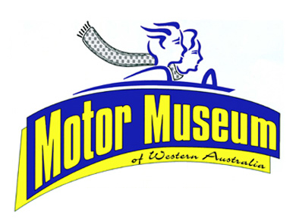

SUNDAY 10th NOVEMBER 2019
THE BROCKWELL CLASSIC CAR RUN

In memory of Maurice Brockwell, this year’s revamped run will start from Whiteman Park and finish at York.

A pleasant drive to York and then enjoy the hospitality of the town, including the revitalised community run York Motor Museum and other attractions. A choice of two routes will be available

The entrance fee remains at $10.00 per vehicle and will include free entry to the Whiteman Park Motor Museum, before 10:15am, for the driver and passengers.

Gates open at 8.00am and first vehicles will depart Whiteman Park from 10.15am

Enquiries: 9249 9457
Mob: 0455 322 282
Email:manager@motormuseumwa.com.au

